**Topics: Descriptive Statistics and Probability**

1. Look at the data given below. Plot the data, find the outliers and find out $μ, σ, σ^{2}$

|  |  |
| --- | --- |
| **Name of company** | **Measure X** |
| Allied Signal | 24.23% |
| Bankers Trust | 25.53% |
| General Mills | 25.41% |
| ITT Industries | 24.14% |
| J.P.Morgan & Co. | 29.62% |
| Lehman Brothers | 28.25% |
| Marriott | 25.81% |
| MCI | 24.39% |
| Merrill Lynch | 40.26% |
| Microsoft | 32.95% |
| Morgan Stanley | 91.36% |
| Sun Microsystems | 25.99% |
| Travelers | 39.42% |
| US Airways | 26.71% |
| Warner-Lambert | 35.00% |

**ANS:**

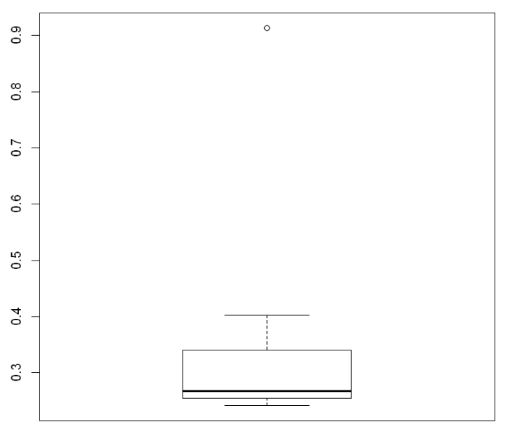

**Mean = 0.332713333333333**

**Sd = 0.16945400921222**

**Var = 0.0287146612380952**



Answer the following three questions based on the box-plot above.

1. What is inter-quartile range of this dataset? (please approximate the numbers) In one line, explain what this value implies.

**ANS: IQR is the range between upper quartile (Q3) and lower quartile (Q1)**

**IQR= Q3-Q1= 12-5 = 7**

**50% of the data lies between IQR**

1. What can we say about the skewness of this dataset?

**ANS: Skewness = Positive**

1. If it was found that the data point with the value 25 is actually 2.5, how would the new box-plot be affected?

**ANS: There will be no outlier if the value of 25 was actually 2.5. Subsequently, mean and median needs to be calculated to see if there is any shift in data**



Answer the following three questions based on the histogram above.

1. Where would the mode of this dataset lie?

**ANS: The mode can lie between 3 and 10 because majority of the entry in this range. To pin point the actual Mode we will have analyze the data**

1. Comment on the skewness of the dataset.

**ANS: Skewness = Positive**

1. Suppose that the above histogram and the box-plot in question 2 are plotted for the same dataset. Explain how these graphs complement each other in providing information about any dataset.

**ANS: There is an outlier of the value 25 and both the plot has positive skewness**

1. AT&T was running commercials in 1990 aimed at luring back customers who had switched to one of the other long-distance phone service providers. One such commercial shows a businessman trying to reach Phoenix and mistakenly getting Fiji, where a half-naked native on a beach responds incomprehensibly in Polynesian. When asked about this advertisement, AT&T admitted that the portrayed incident did not actually take place but added that this was an enactment of something that “could happen.” Suppose that one in 200 long-distance telephone calls is misdirected. What is the probability that at least one in five attempted telephone calls reaches the wrong number? (Assume independence of attempts.)

**ANS: X = probability of 1 call misdirected out of 200**

**Probability of occurring of X = 1/200**

**P(X)= 1/200**

**Probability of having at least one successful call will be**

**1-P(X)= 1-1/200= 199/200= 0.967**

**As every event is independent of other event the probability will be**

**1- (0.967)^5**

**0.02475 = 2% chance.**

1. Returns on a certain business venture, to the nearest $1,000, are known to follow the following probability distribution

|  |  |
| --- | --- |
| x | P(x) |
| -2,000 | 0.1 |
| -1,000 | 0.1 |
| 0 | 0.2 |
| 1000 | 0.2 |
| 2000 | 0.3 |
| 3000 | 0.1 |

1. What is the most likely monetary outcome of the business venture?

**ANS: $2000 as it has the highest probability of occurrence**

1. Is the venture likely to be successful? Explain

ANS: if Success == positive returns as a measure

Then there is a 60% probability that the venture would be successful (0.3+0.2+0.1=0.6=>0.6*100=>60%).

1. What is the long-term average earning of business ventures of this kind? Explain

**ANS: (-2000*0.1)+(-1000*0.1)+(0*0.2)+(1000*0.2)+(2000 *0.3)+(3000*0.1)=800**

**the long-term average earning for these type of ventures would be around $800**

1. What is the good measure of the risk involved in a venture of this kind? Compute this measure

**ANS: A good measure to evaluate the risk would be variance and standard deviation of the variable x**

**Var = 3500000**

**Sd = 1870.83**

**The large value of standard deviation of $1870 is considered along with the average returns of $800 indicates that this venture is highly risky**